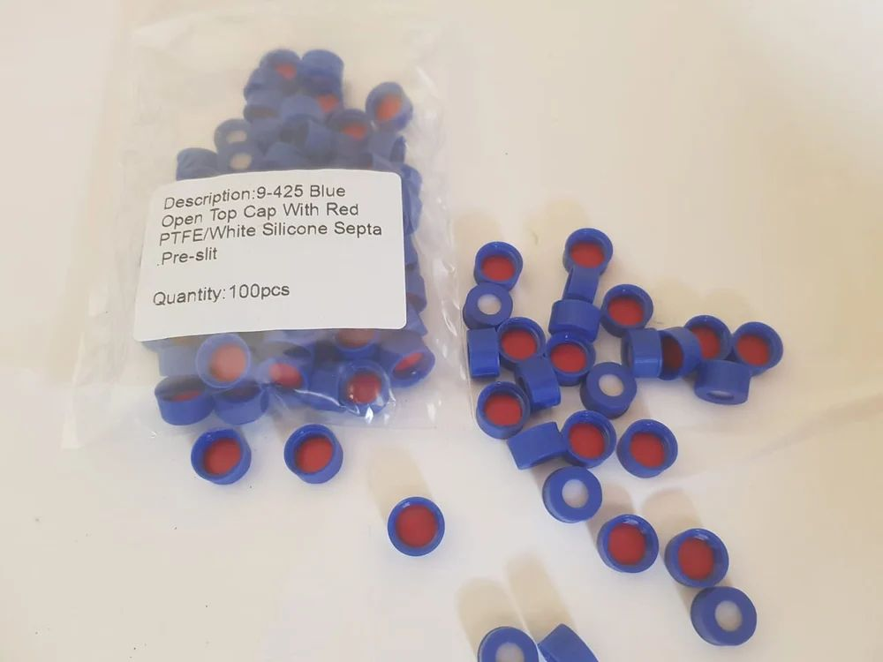

1a) The cap feature 9mm ± 1mm wide opening minimum of 6mm hole with pre-slit septum.

2a) The cap able to fit with a 12 x 32mm, 2mL screw top vial, without any visible tilting

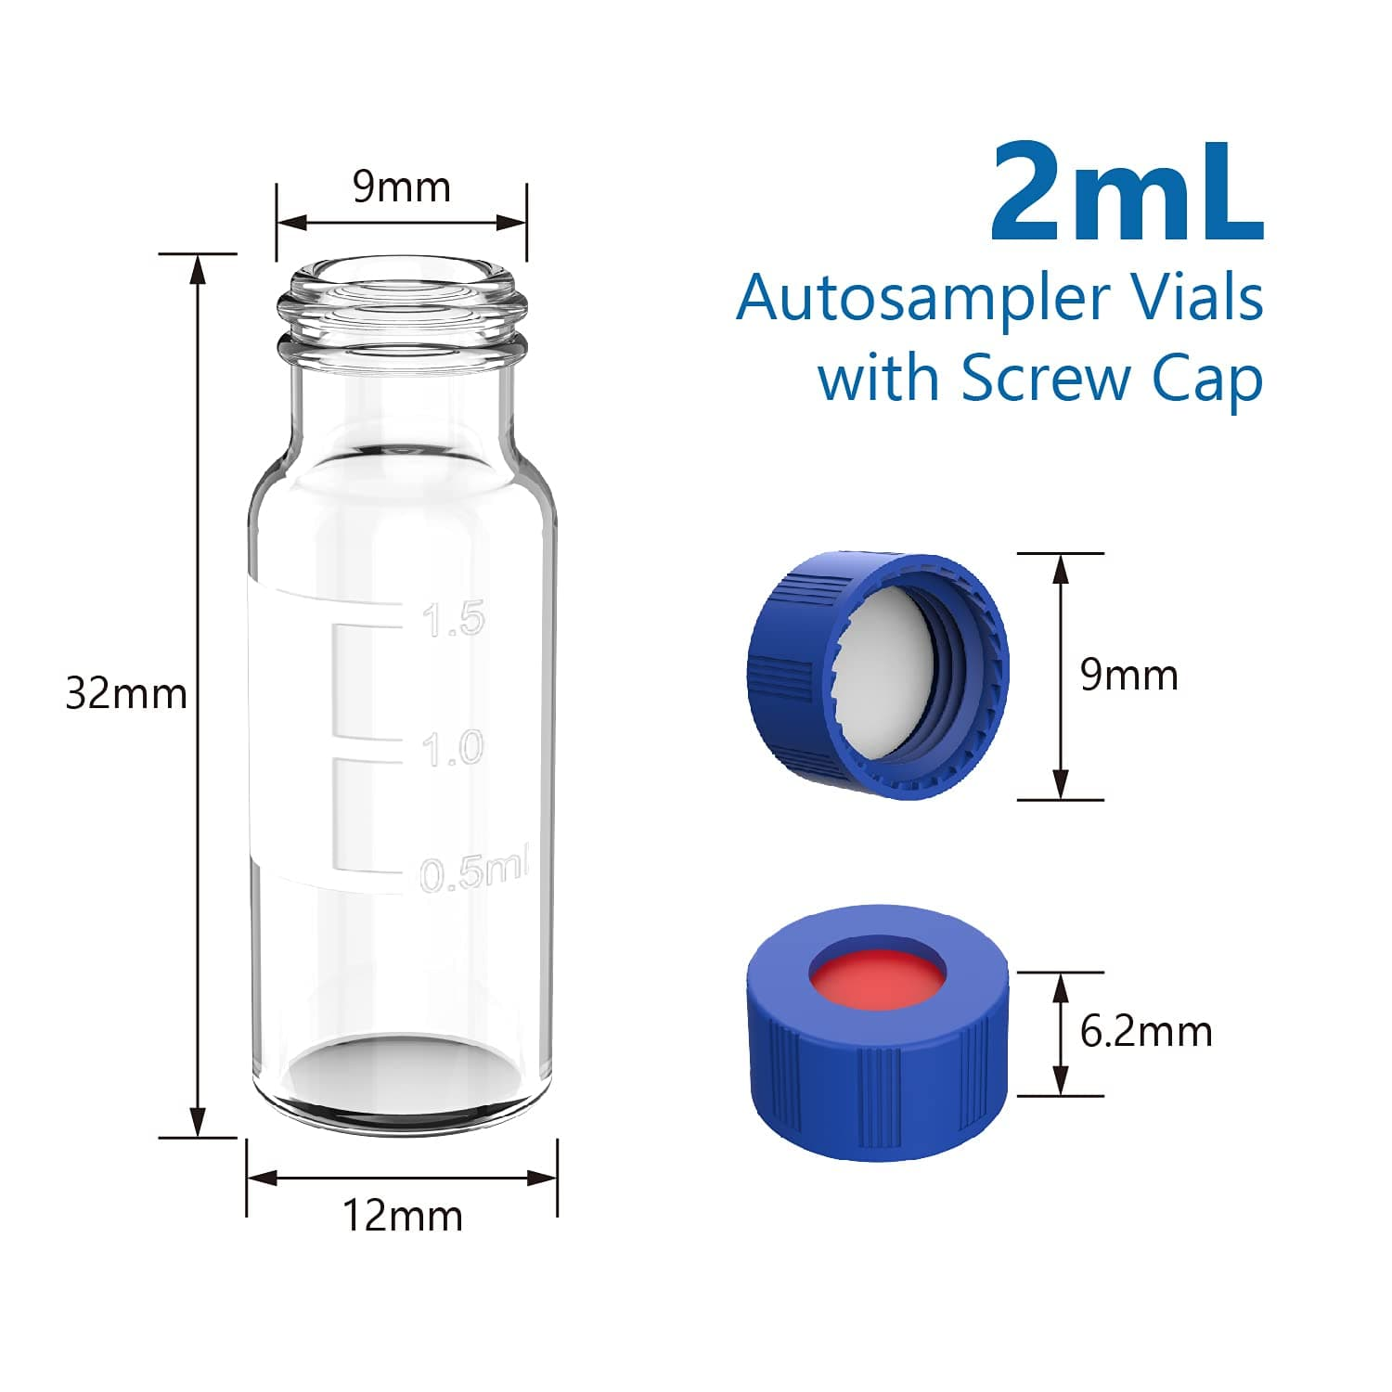

The cap must be able to fit with a 12 x 32mm, 2mL screw top vial,

without any visible cap tilting.

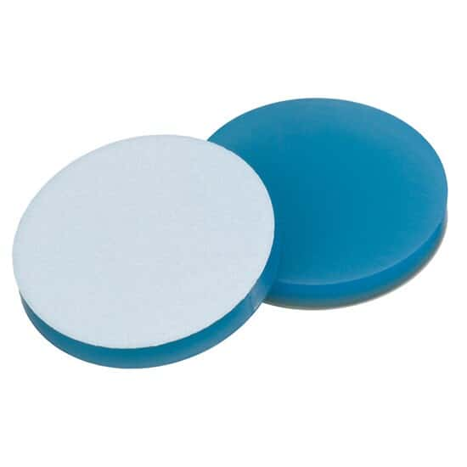

The septum must be pre-slit and made of polytetrafluoroethylene

(PTFE) / Silicone materials - The top layer facing the needle is

silicone and the bottom layer facing the sample is PTFE. The

silicone layer must be approximately 1 mm thick.

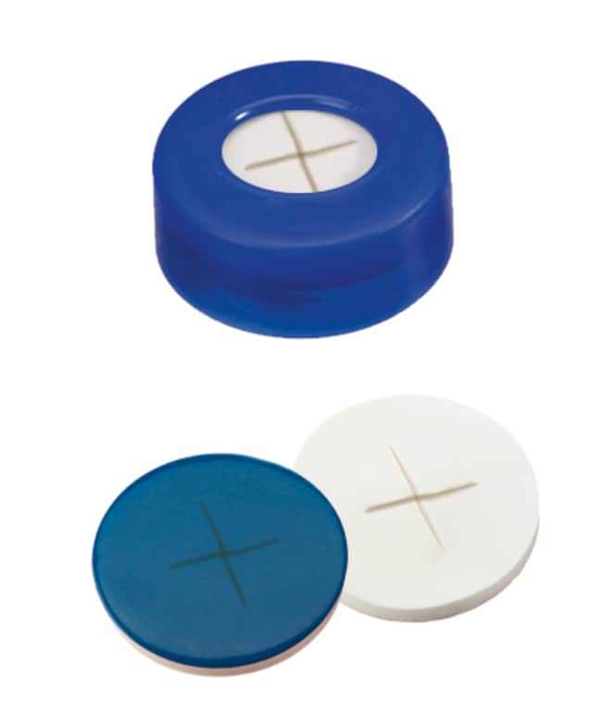

The hole must be at the middle of the cap with the slit on the

septum at the middle of the hole

The septum must not dislodge from the cap after injection.

The cap must be LCMS certified and compatible for use on

LC/MS/MS instruments

The septum must be able to withstand a minimum of 5 injections,

both manually and automatically (by LC/MS/MS instruments)

using syringe needle, with capability to seal without any sign of

dislodging of the septum materials

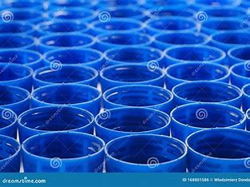

The cap must be made of chemically inert material e.g.

Polyethylene.

All deliveries shall be accompanied with the delivery order and

the document that certified that the caps are LCMS certified.

**Firm: - 3 Years**

**1** Year 1: LCMS certified Pre-slit caps 50,000 pieces

**2** Year 2: LCMS certified Pre-slit caps 50,000 pieces

**3** Year 3: LCMS certified Pre-slit caps 50,000 pieces

**Confirm – Upon no mistake found**

Year 4: LCMS certified Pre-slit caps 50,000 pieces

**5** Year 5: LCMS certified Pre-slit caps 50,000 pieces