Document for Tender on PI and Packing
Additional info.
- Performa Invoice must show to Buyer information and sending to buyer courier.
- Must show the manufacturer and expire date, description of Item and the quantity.
- Price must be tender price otherwise cannot accept, as we only pay out courier service.
- Payment terms preference 30/70% of the cost unless otherwise.

- Packing list must show size LxBxH and weigh of each carton. CBM are not able to work out the cost.
- When there is colour chart please put there as well.

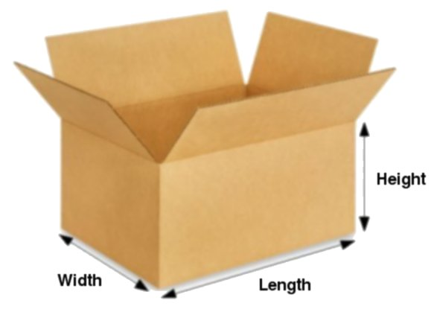 Box prefer to give total qty of the item in a carton LxBxH and weigh.

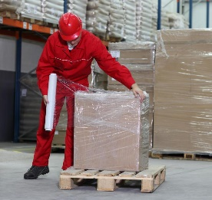 Prefer to be wrap individually or …

 Pallet wraps not over the height of a person. Easy to count.

